**Database Systems Lab**

**(CL2005)**

**Final Project Report**

**Bank Management System**

**By:**

* Aashir Adnan (22L-6753)
* Muhammad Ahmad Raza (22L-6700)
* Maira Izhar (22L-6626)

**Section:** BCS-4G-1

**Presented to:**

* Ma’am Zoha Waheed
* Ma’am Zareen Alamgir

**Table Of Contents**

1. 'Table' section 3

Table Table 3

Column(s) of "Accounts" Table 3

Child Relationship(s) of "Accounts" Table 3

Column(s) of "Admins" Table 3

Column(s) of "Bills" Table 3

Parent Relationship(s) of "Bills" Table 3

Column(s) of "Cards" Table 3

Parent Relationship(s) of "Cards" Table 3

Column(s) of "Complaints" Table 4

Parent Relationship(s) of "Complaints" Table 4

Column(s) of "Heirs" Table 4

Parent Relationship(s) of "Heirs" Table 4

Column(s) of "Loans" Table 4

Parent Relationship(s) of "Loans" Table 4

Column(s) of "SignUp" Table 4

Column(s) of "Transactions" Table 4

Parent Relationship(s) of "Transactions" Table 4

1. 'Picture' section 4

Main Subject Area/Display1 5

Index

**Table**

|  |
| --- |
| **Table** |
| **Name** |
| Accounts |
| Admins |
| Bills |
| Cards |
| Complaints |
| Heirs |
| Loans |
| SignUp |
| Transactions |

|  |  |  |  |  |
| --- | --- | --- | --- | --- |
| **Column(s) of "Accounts" Table** | | | | |
| **Name** | **Datatype** | **Is PK** | **Is FK** | **Null Option** |
| User ID | INTEGER | Yes | No | NOT NULL |
| Full Name | VARCHAR(255) | No | No | NOT NULL |
| CNIC | CHAR(13) | No | No | NOT NULL |
| User Name | VARCHAR(50) | No | No | NOT NULL |
| Password | VARCHAR(255) | No | No | NOT NULL |
| Account Type | VARCHAR(50) | No | No | NOT NULL |
| Balance | DECIMAL(10,2) | No | No | NULL |
| Heirs | INTEGER | No | No | NULL |
| Account Status | BINARY | No | No | NOT NULL |

|  |  |
| --- | --- |
| **Child Relationship(s) of "Accounts" Table** | |
| **FK Name** | **Cardinality** |
| R/2 | One-to-Zero-One-or-More |
| R/4 | One-to-Zero-One-or-More |
| R/5 | Zero-or-One-to-Zero-One-or-More |
| R/7 | One-to-Zero-One-or-More |
| R/9 | One-to-Zero-One-or-More |
| R/11 | One-to-Zero-One-or-More |
| R/14 | One-to-Zero-One-or-More |
| R/15 | One-to-Zero-One-or-More |

|  |  |  |  |  |
| --- | --- | --- | --- | --- |
| **Column(s) of "Admins" Table** | | | | |
| **Name** | **Datatype** | **Is PK** | **Is FK** | **Null Option** |
| Full Name | VARCHAR(255) | No | No | NOT NULL |
| CNIC | CHAR(13) | No | No | NOT NULL |
| User Name | VARCHAR(50) | No | No | NOT NULL |
| Password | VARCHAR(255) | No | No | NOT NULL |
| User ID | INTEGER | Yes | No | NOT NULL |

|  |  |  |  |  |
| --- | --- | --- | --- | --- |
| **Column(s) of "Bills" Table** | | | | |
| **Name** | **Datatype** | **Is PK** | **Is FK** | **Null Option** |
| Transaction Amount | DECIMAL(10,2) | No | No | NOT NULL |
| Date | DATE | No | No | NOT NULL |
| Receiver ID | INTEGER | No | Yes | NOT NULL |
| User ID | INTEGER | No | Yes | NOT NULL |
| Bill ID | INTEGER | Yes | No | NOT NULL |

|  |  |
| --- | --- |
| **Parent Relationship(s) of "Bills" Table** | |
| **Cardinality** | **FK Name** |
| One-to-Zero-One-or-More | R/14 |
| One-to-Zero-One-or-More | R/15 |

|  |  |  |  |  |
| --- | --- | --- | --- | --- |
| **Column(s) of "Cards" Table** | | | | |
| **Name** | **Datatype** | **Is PK** | **Is FK** | **Null Option** |
| User ID | INTEGER | No | Yes | NOT NULL |
| Card Type | VARCHAR(50) | No | No | NOT NULL |
| Limit | DECIMAL(10,2) | No | No | NOT NULL |
| Card ID | INTEGER | Yes | No | NOT NULL |

|  |  |
| --- | --- |
| **Parent Relationship(s) of "Cards" Table** | |
| **Cardinality** | **FK Name** |

|  |  |
| --- | --- |
| One-to-Zero-One-or-More | R/7 |

|  |  |  |  |  |
| --- | --- | --- | --- | --- |
| **Column(s) of "Complaints" Table** | | | | |
| **Name** | **Datatype** | **Is PK** | **Is FK** | **Null Option** |
| User ID | INTEGER | No | Yes | NOT NULL |
| Complaint | TEXT | No | No | NOT NULL |
| Complaint ID | INTEGER | Yes | No | NOT NULL |

|  |  |
| --- | --- |
| **Parent Relationship(s) of "Complaints" Table** | |
| **Cardinality** | **FK Name** |
| One-to-Zero-One-or-More | R/2 |

|  |  |  |  |  |
| --- | --- | --- | --- | --- |
| **Column(s) of "Heirs" Table** | | | | |
| **Name** | **Datatype** | **Is PK** | **Is FK** | **Null Option** |
| User ID | INTEGER | Yes | Yes | NOT NULL |
| Heir Name | VARCHAR(255) | No | No | NOT NULL |
| Heir CNIC | CHAR(13) | No | No | NOT NULL |
| Relation | VARCHAR(50) | Yes | No | NOT NULL |

|  |  |
| --- | --- |
| **Parent Relationship(s) of "Heirs" Table** | |
| **Cardinality** | **FK Name** |
| One-to-Zero-One-or-More | R/4 |

|  |  |  |  |  |
| --- | --- | --- | --- | --- |
| **Column(s) of "Loans" Table** | | | | |
| **Name** | **Datatype** | **Is PK** | **Is FK** | **Null Option** |
| User ID | INTEGER | No | Yes | NOT NULL |
| Amount Requested | DECIMAL(10,2) | No | No | NOT NULL |
| Date | DATE | No | No | NOT NULL |
| Loan ID | INTEGER | Yes | No | NOT NULL |

|  |  |
| --- | --- |
| **Parent Relationship(s) of "Loans" Table** | |
| **Cardinality** | **FK Name** |
| Zero-or-One-to-Zero-One-or-More | R/5 |

|  |  |  |  |  |
| --- | --- | --- | --- | --- |
| **Column(s) of "SignUp" Table** | | | | |
| **Name** | **Datatype** | **Is PK** | **Is FK** | **Null Option** |
| Full Name | VARCHAR(255) | No | No | NOT NULL |
| CNIC | CHAR(13) | No | No | NOT NULL |
| User Name | VARCHAR(50) | No | No | NOT NULL |
| Password | VARCHAR(255) | No | No | NOT NULL |
| Account Type | VARCHAR(50) | No | No | NOT NULL |
| Request Status | BINARY | No | No | NOT NULL |
| Request ID | INTEGER | Yes | No | NOT NULL |

|  |  |  |  |  |
| --- | --- | --- | --- | --- |
| **Column(s) of "Transactions" Table** | | | | |
| **Name** | **Datatype** | **Is PK** | **Is FK** | **Null Option** |
| Date | DATETIME DAY TO SECOND | No | No | NOT NULL |
| Amount | DECIMAL(10,2) | No | No | NOT NULL |
| Receiver ID | INTEGER | No | Yes | NOT NULL |
| Sender ID | INTEGER | No | Yes | NOT NULL |
| Transaction ID | INTEGER | Yes | No | NOT NULL |

|  |  |
| --- | --- |
| **Parent Relationship(s) of "Transactions" Table** | |
| **Cardinality** | **FK Name** |
| One-to-Zero-One-or-More | R/9 |
| One-to-Zero-One-or-More | R/11 |

**Main Subject Area/Display1**

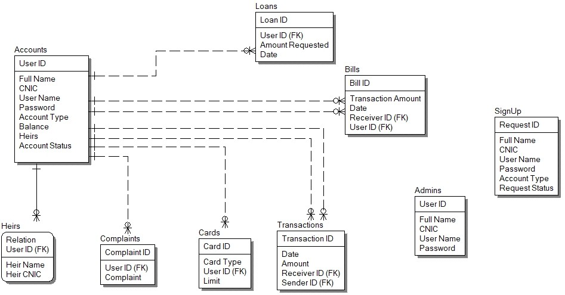

**Index**

# A

Account Status 3

Account Type 3, 4

Accounts 3

Admins 3

Amount 4

Amount Requested 4

# B

Balance 3

Bill ID 3

Bills 3

# C

Card ID 3

Card Type 3

Cards 3

CNIC 3, 4

Complaint 4

Complaint ID 4

Complaints 3, 4

# D

Date 3, 4

# F

Full Name 3, 4

# H

Heir CNIC 4

Heir Name 4

Heirs 3, 4

# L

Limit 3

Loan ID 4

Loans 3, 4

# M

Main Subject Area/Display1 5

# P

Password 3, 4

# R

R/11 3, 4

R/14 3

R/15 3

R/2 3, 4

R/4 3, 4

R/5 3, 4

R/7 3, 4

R/9 3, 4

Receiver ID 3, 4

Relation 4

Request ID 4

Request Status 4

# S

Sender ID 4

SignUp 3, 4

# T

Transaction Amount 3

Transaction ID 4

Transactions 3, 4

# U

User ID 3, 4

User Name 3, 4